**News Bulletin**

**October 2023**

**WELCOME**

We would like to say THANK YOU to all our patients, for your patience throughout the year. We are continually being encouraged by NHS England to make changes to improve the service for you, so your patience & understanding is much appreciated!

The surgery offers increased access appointments on Tuesday evening’s & one Saturday each month, to allow patients more flexibility to book a GP or Nurse appointment.

**Appointments / Did Not Attends (DNA’s)**

Below are appointments wasted where patients have failed to attend between

1st of September 23 to the 31st of September 23.

* Phlebotomy – **16 failed to attend.**
* HCA Appointments (Bloods, BP Checks, INRs, etc) – **15 failed to attend**
* Nurse Appointments (Vaccines, Smears, Bloods, etc) – **21 failed to attend**
* Doctor Appointments – **25 failed to attend**
* Mental Health Practitioner – **1 failed to attend**
* Podiatrist – **2 failed to attend**

This totals 24 hours’ worth of appointments that could have been offered to other patients.

If you cannot attend an appointment, please always cancel it so that we can offer the appointment to someone else.

GP Consultations

At Dr Dawoud’s Surgery, we have a ‘One Problem Per Consultation’ Policy.

Please can we kindly ask that all patients seeing the Doctor stick to our ‘One Problem Per Consultation’ Policy.

We know that getting an appointment with the doctor is sometimes difficult. We also know that the clinician may run late. All of this increases the tendency for patients to present multiple problems to their Doctor/ANP at one consultation.

Each appointment is only 10 minutes long.

Presenting the clinician with multiple problems means that there is an increased risk that mistakes will be made, and things could be missed as the clinician may be inclined to rush, especially if other patients are waiting.

Please do not be offended if the doctor asks you to rebook for your other problems.

We always encourage patients to book double appointments if there are multiple problems that need discussing.

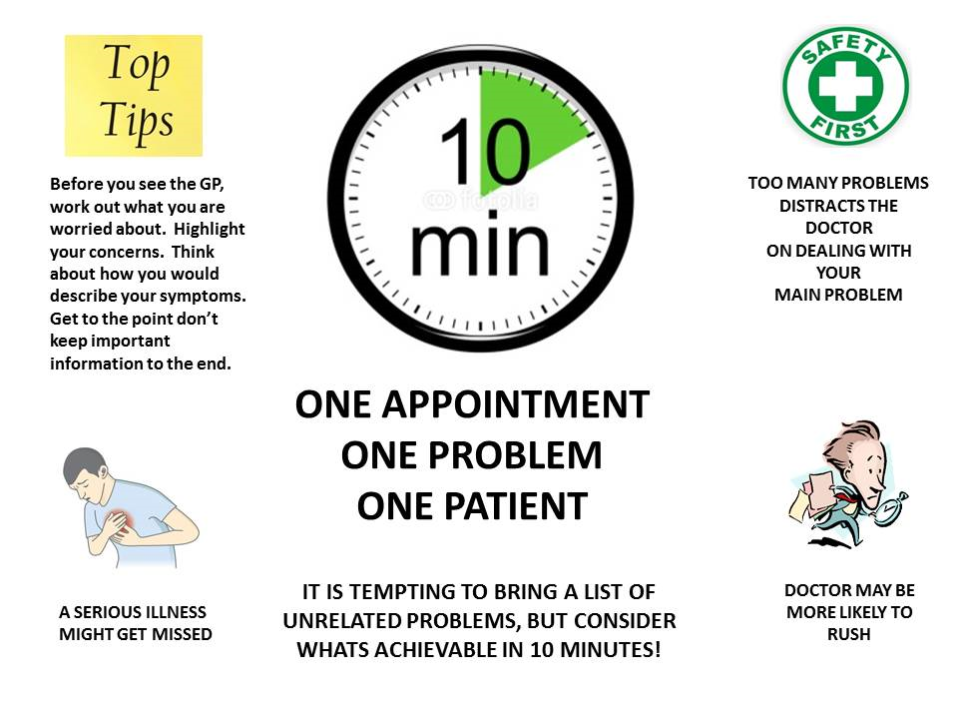

**Appointments**

We have pre-bookable appointments for patients to book, these are available to book on-line via the NHS App, please download the appt today! You can also call the surgery to book.

On the day are urgent appointments are for urgent only issues.



**We have some birthdays to celebrate in**

**September**

**Lauren & Sylvia**

***Many Happy Returns to you all***

**Current Health Campaigns September**

**September**

Organ Donation Week 2nd-8th September

Organ Donation Week is a week-long celebration of organ donation across the UK, and this year’s event is a great opportunity for donor families, transplant patients, the wider NHS and organisations to reinforce the importance of organ donation. Next year, the law around organ donation is changing in [England](https://www.organdonation.nhs.uk/uk-laws/organ-donation-law-in-england/) and [Scotland](https://www.organdonation.nhs.uk/uk-laws/organ-donation-law-in-scotland/). From spring 2020 in England and autumn 2020 in Scotland, all adults will be considered as having agreed to donate their own organs when they die unless they record a decision not to donate or are in one of the excluded groups.



World Suicide Prevention Day 10th September

World Suicide Prevention Day promotes worldwide commitment and action to prevent suicides. The World Health Organization (WHO) reports that someone takes their own life every 40 seconds. That’s about 800,000 people worldwide every year. Suicide is the leading cause of death for people aged 15 to 29. And for every suicide that results in death, there are as many as 40 attempted suicides.

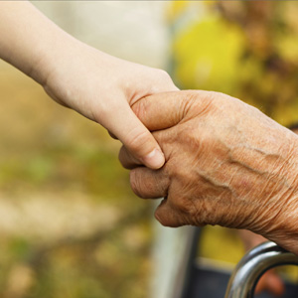

Drink Free Days 10th September – 11th November

The Drink Free Days campaign encourages people to think about how much they are drinking and to highlight that having more Drink Free Days can improve their health. The short and long-term effects of alcohol can affect your body, lifestyle and mental health.

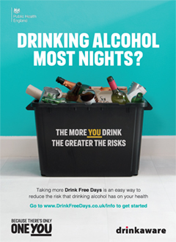

World’s Biggest Coffee Morning – 27th September

People all over the UK host their own Coffee Mornings and donations on the day are made to Macmillan. Having a Coffee Morning is the perfect chance to catch up over a cuppa and a slice of something delicious for a great cause. One in two of us will face cancer, and the money you raise at your Coffee Morning will help everyone with cancer to live life as fully as they can.



Flu Vaccine

IF YOU HAVENT HAD YOUR FLU VACCINE PLEASE BOOK YOUR APPOINTMENT, THIS IS IMPORTANT FOR YOUR HEALTH THROUGHOUT THE WINTER MONTHS!

**Carers & Flu Vaccines**

Carers are entitled to a flu vaccine and health check.

As a carer we understand that your time is limited, we will always try to accommodate your needs of care.

The carers health check provides one to one time with our health care assistant to have a chat about your general health, lifestyle, and well-being.

If you need further support referrals can be made to Lancashire Carers/N Compass, website <https://www.n-compass.org.uk> who can advise on what help is available to you in our community.

**New Mental Health Worker**

For any patient that is feeling isolated or lonely this winter please do contact the surgery, we are here to help and signpost you to new services that are available.

We have a new Mental Health Practitioner Lauren, who works every Thursday at the surgery and is available for face-to-face appointments for patients dealing with low mood, anxiety, or depression etc.

The NHS has a new volunteer service that encourages patients to pick up the phone and talk to someone when feeling alone.

Patients can self-refer by calling 0808 196 3646 for further information visit the website <https://nhscarevolunteerresponders.org/services>

Patients can refer directly to Minds Matters for help with a variety of mental health symptoms. <https://www.lscft.nhs.uk/talking-therapies/self-referral>

Lancashire County Council has a Social Prescriber who offers telephone or face to face appointments at the surgery and can help patients needing financial and benefits advice to connecting patients with supportive groups in our community.

It can be difficult reaching out and accepting that we might need help. Our team understands how challenging life can be at times and we want our patients to know we are here to help you!

First Contact Physiotherapy

Appointments are now available at Dr Dawoud’s Surgery with Richard our Practitioner if you have musculoskeletal pain (muscles or joints) Richard will be your first contact.

You do not need to see a doctor first.

You will be booked in with the Practitioner. Please see below for the criteria.

Self-Care/Minor Ailment Scheme at the pharmacy

A large range of common illnesses and injuries can be treated at home simply with over-the-counter medicines and plenty of rest.

We can now refer you to a pharmacist for an appointment, please see conditions below.

Treatment for the following:

* Minor aches & pains
* Minor sprains, sport injuries, grazed knee and scars
* Coughs, colds, blocked noses, fevers and sore throat
* Hangover
* Athletes foot
* Constipation, diarrhoea and haemorrhoids (piles)
* Dry skin
* Hayfever and allergies
* Headlice (wet combing is recommended)
* Indigestion remedies (for occasional use)

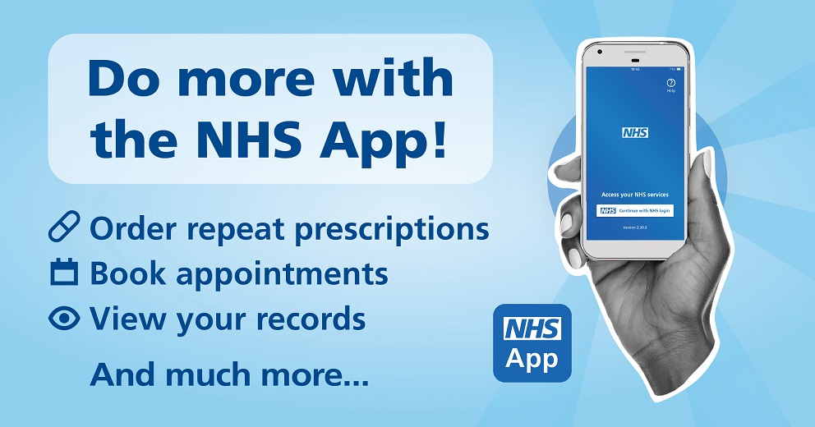

NHS App

If you’re a patient at our practice, you can use the NHS App to access a range of NHS services on your smartphone or tablet.

Once you have verified your identity you will have easy, 24/7 access to a growing range of health services and information!

You can:

* Order repeat prescriptions.
* Access NHS 111 online.
* View your health records.
* Book appointments.
* Find NHS services.
* And much more!

If you have any problems using the NHS App, you can select ‘help’ in the top right-hand corner of the app or visit [nhs.uk/helpmeapp](http://nhs.uk/helpmeapp) – **Alternatively, we are here to help you, just ask a receptionist.**



**Health Campaigns**

**Movember**

Movember is about raising awareness around men’s health. Movember is specifically about prostate cancer, testicular cancer, mental health, and suicide prevention.

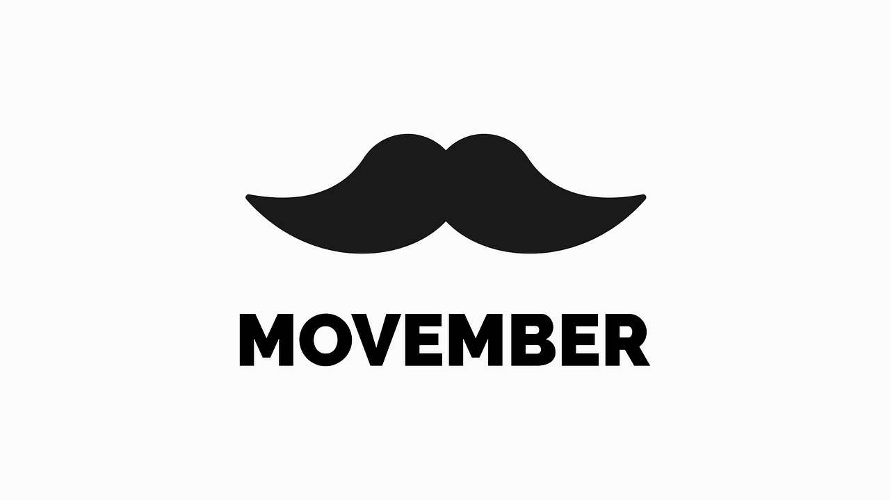

**For more campaigns and information, please have a read on our website.**

[**https://www.drdawoudssurgery.co.uk/**](https://www.drdawoudssurgery.co.uk/)

**Closed for Protected Education Training Sessions (PETS) &**

**Bank Holidays 2023 - Jan 2024**

The Surgery will be closed on the below dates for our PETS. We will reopen the following day at 8am.

Tuesday 7th November between 13:00 & 18:30

The surgery will be closed on the below dates for Bank Holidays.

Monday 25th December

Tuesday 26th December

**Thank you and keep safe!**